GRATR Presentation v1

GRATR Presentation

Slide 1 — Title Page
- GRATR: An Ethical Community Centre for LGBTQ+ Connection
- Nick Gellatly | Digital Media Production Student | Anglia Ruskin University
- User Experience Design | Semester 1, Year 1
- Building safer, kinder digital spaces beyond the city limits
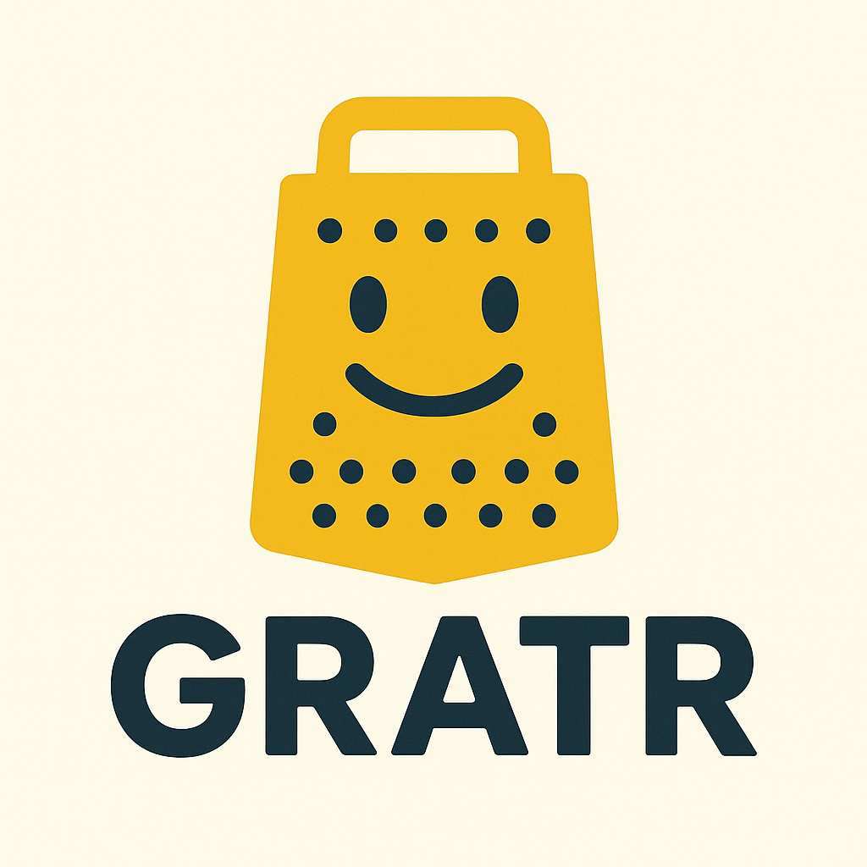


Slide 2 — Problem & Context
- Social media prioritises profit over people, using addictive design and behavioural manipulation (Jaron Lanier's "BUMMER" model)
- Platforms undermine autonomy, truth, empathy, and mental health through algorithmic exploitation
- Current apps fail LGBTQ+ users through privacy breaches, superficiality, and inadequate safety measures


Image: Split-screen visual: one side showing tangled, dark algorithm networks; other side showing a clear, open community space.

Slide 3 — Intrusive & Damaging Features
- Grindr exposes minors to exploitation (100+ cases since 2015) through weak age verification
- Real-time location tracking creates safety risks; sensitive health data shared without adequate protection
- Addictive design and appearance-based interactions harm self-esteem and promote compulsive use


Image: Warning/caution iconography with location pins, notification symbols, and data streams in concerning red tones

Slide 4 — Concept Overview
- GRATR = "Greater" social media – a virtual Community Centre - doing everything better, safer, and more ethically
- Multi-purpose social utility hub: Community, Connections, Social Life, Food & Drink, Shopping
- Grassroots aesthetic inspired by activist campaigns; authentic and human, not corporate

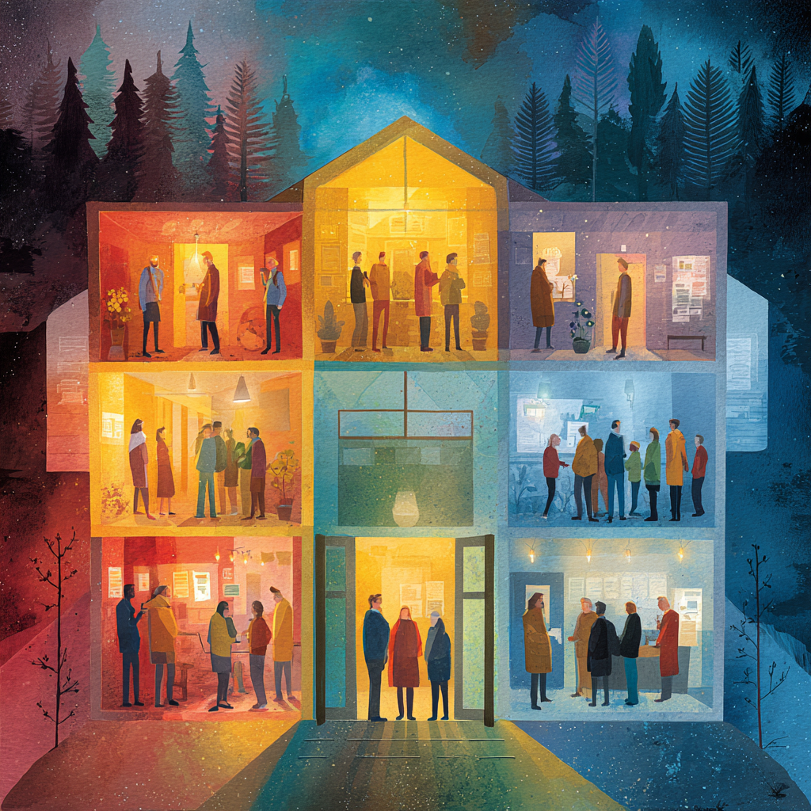
Image: Community centre building with welcoming "rooms" or sections glowing warmly, surrounded by diverse people

Slide 5 — Who It's For
- LGBTQ+ individuals in "social deserts"—small cities, suburbs, rural areas lacking community resources
- Three personas: The Isolated Seeker (safety/belonging), Local Organiser (community building), Ethical Dater (authentic connection)
- Research shows 61% face discrimination: higher psychological distress outside urban centres


Image: Map showing connections lighting up across rural/suburban landscapes, not just concentrated in city centres

Slide 6 — Key Ethical Principles
- Privacy & Safety: Regional filtering (not GPS), mandatory age verification, no third-party data sharing
- Addiction Safeguarding: Daily limits, "Pause" mode, delayed photo reveals prioritize values over appearance
- Governance: Zero-tolerance policy, Community Review Board, anti-discrimination filters banned



Image: Shield representing each principle, in trustworthy blue and green tones

Slide 7 — Main Feature
- GRATR Community: A Virtual Community Centre – in other words, a Village Hall for Village People
- What’s in the Community Centre?
- Education Groups – Conversational French, Photography; Social Gatherings – Line Dancing, Coffee Mornings, Slimming World; Special Events – Weddings, Produce Show, Fetes; Exercise and Wellness – Pilates, Tai Chi, Keep Fit, Yoga, Zumba; Community Meetings – Protest, Politics, Public Meetings

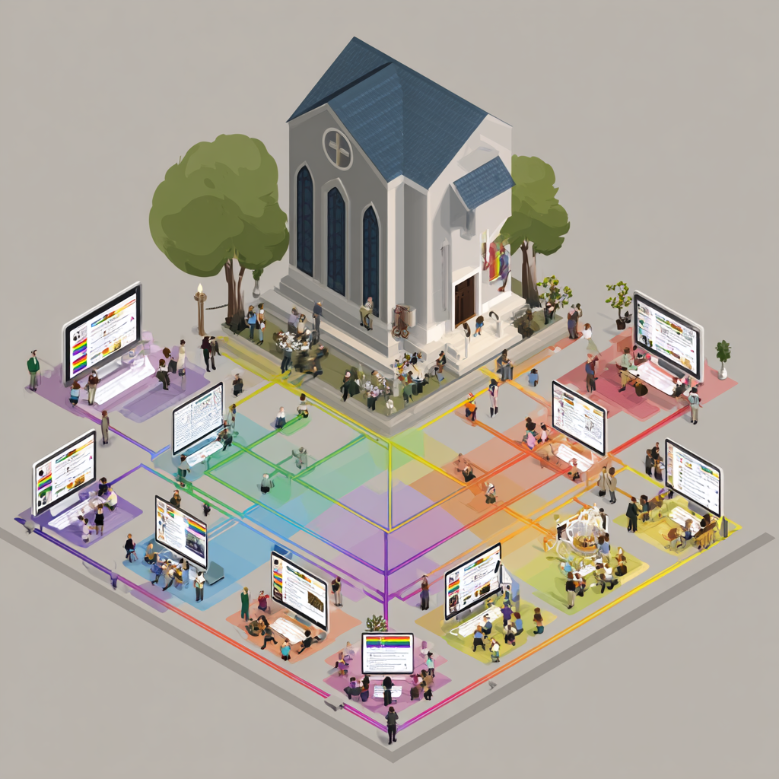
Image: A virtual community centre online, representing each section of the LGBTQ+ community in a supportive network structure

Slide 8 — User Journey Map
- Five-part navigation bar provides instant access to all platform functions
- Universal toolbar includes global search, notifications, and consistent accessibility controls
- Every section features granular accessibility filters and community-driven reviews

Image: Simple user flow diagram showing a journey from landing page through connection to community event

Slide 9 — Wireframes (Screen-by-Screen)
- Clean, minimalist interface prioritizing content readability over engagement tricks
- Prominent safety features and accessibility controls on every screen
- Navigation designed for clarity and autonomy, not infinite scrolling

Image: Grid of simple wireframe sketches showing key screens (login, home, profile, group page)

Slide 10 — Prototype Walkthrough
- Grassroots aesthetic with warm, inclusive color palette and clear typography
- Accessibility-first design with high contrast options and adjustable text sizing
- Community-focused layouts that promote deliberate interaction over compulsive engagement

XD

Image: 2-3 high-fidelity mockup screens showing actual visual design with your color scheme

Slide 11 — Ethical Safeguards
- No infinite scroll or proximity-based "nearby" features that encourage compulsion
- Wellbeing reminders, daily interaction limits, and mandatory breaks built into design
- Privacy-preserving verification prevents surveillance while ensuring safety

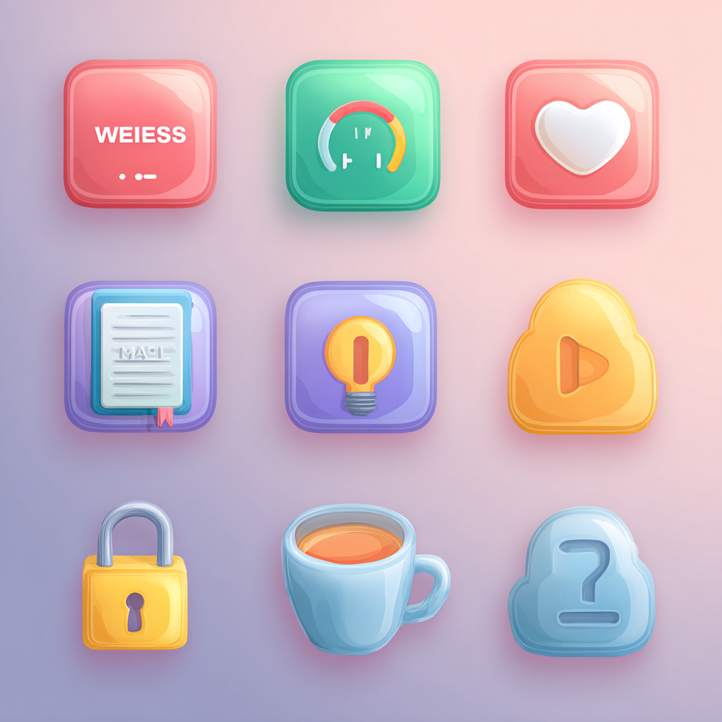

Image: Wellness icons (pause button, daily limit gauge, privacy lock) in calming, supportive colours

Slide 12 — Monetisation Strategy
- Platform Cooperative model: users are co-owners with democratic voting rights
- Sliding-scale membership (£1 lifetime to supporter tiers), optional transaction fees for businesses
- No surveillance advertising, no data extraction—optimizing for community value, not profit

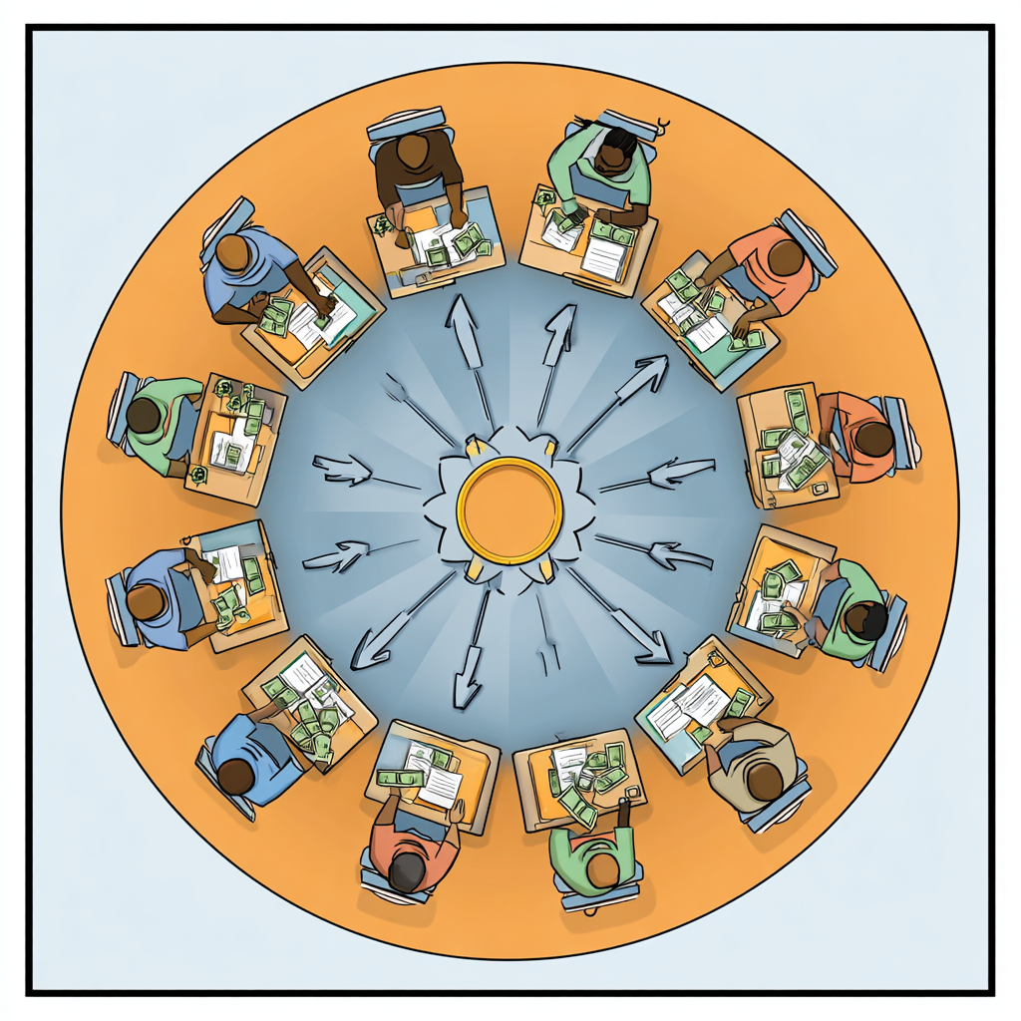
Image: Cooperative circle diagram showing members at center, with revenue flowing back into community

Slide 13 — Why It Will Work
- Unmet need: LGBTQ+ individuals in non-urban areas report high isolation and lack of resources
- Growing ethical tech movement and rejection of exploitative platforms
- Unique position as comprehensive community utility, not just another dating app



Image: Upward trend graph or growing plant metaphor showing community growth and sustainability

Slide 14 — UX Tools & Methods Used
- Research-driven personas based on academic studies of LGBTQ+ isolation and needs
- Iterative wireframing and prototyping focused on accessibility and ethical interaction
- User-centred design principles applied throughout development process

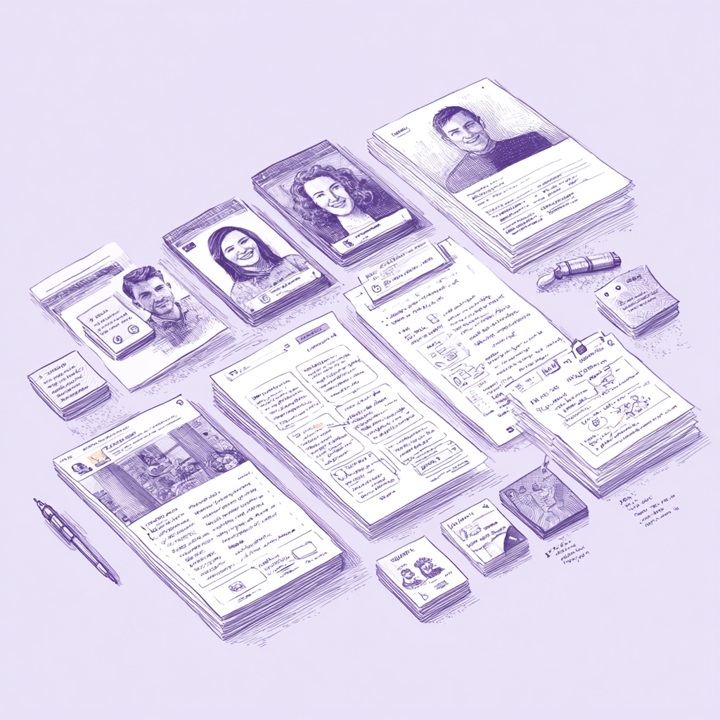
Image: UX toolkit illustration showing persona cards, wireframe sketches, and user testing notes

Slide 15 — Learning Outcomes Demonstrated
- Applied UX theories: ethical design, accessibility standards, community-centered development
- Demonstrated independent research synthesizing academic and industry sources
- Integrated complex requirements into coherent, functional platform design

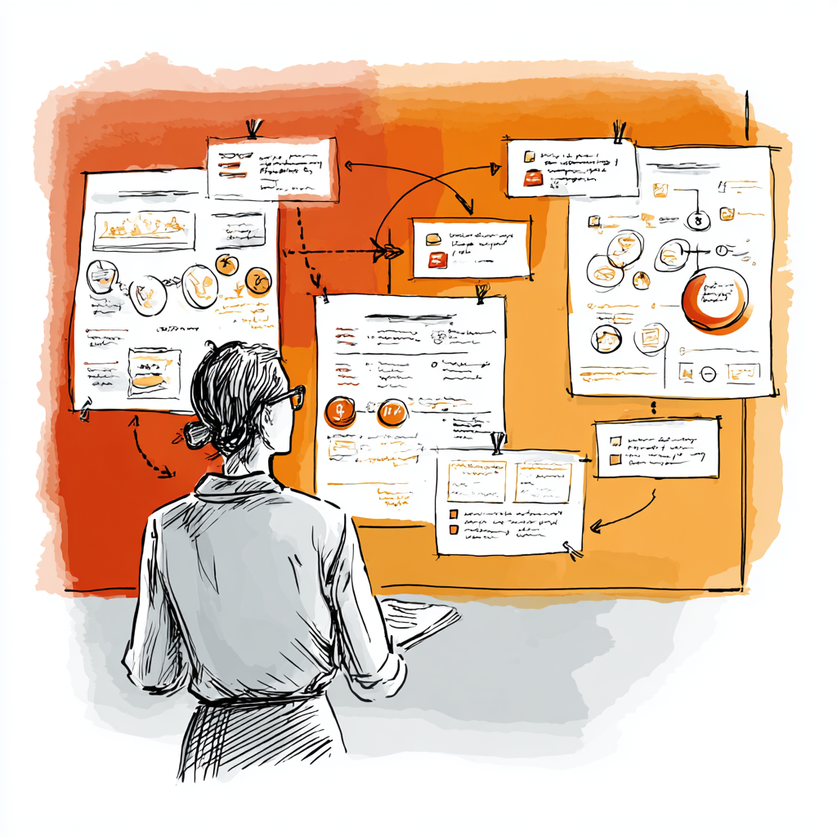

Image: Simple diagram connecting learning outcomes to project deliverables

Slide 16 — Conclusion
- GRATR transforms social deserts into thriving communities through ethical, accessible design
- Proves social media can prioritize wellbeing, safety, and authentic connection over profit
- A digital community centre where every member matters and belongs


Image: Inspiring vista: diverse group silhouettes on a horizon, connected by gentle light threads, looking toward bright future

Slide 17 — References and Thanks
- Academic sources on LGBTQ+ isolation and rural community needs
- Jaron Lanier's critique of social media and ethical tech movement literature
- Platform cooperative models and case studies (Hylo, Stocksy United)
- With thanks to Tina Burton, Nurbanu Asena and my fellow Year 1 Students for their support and kindness.

Sources:
- https://www.penguin.co.uk/books/438053/ten-arguments-for-deleting-your-social-media-accounts-right-now-by-jaron-lanier/9781529112405
- https://mindful.technology/jaron-lanier-delete-social-media/
- https://www.goodreads.com/book/show/37830765-ten-arguments-for-deleting-your-social-media-accounts-right-now
- https://fourminutebooks.com/ten-arguments-for-deleting-your-social-media-accounts-right-now-summary/
- https://ngathanblog.wordpress.com/2018/11/19/book-review-10-arguments-for-deleting-social-media-accounts-by-janron-lanier/
- https://www.faisaljamshaid.com/books/10-reasons-to-delete-your-social-media-accounts-right-now
- https://www.punkt.ch/it/ispirazioni/libreria/ten-arguments
- https://www.youtube.com/watch?v=lXNfZEHXgEA
- https://www.reddit.com/r/20minutebooks/comments/1h4vkxb/ten_arguments_for_deleting_your_social_media/
- https://www.visualsynopsis.com/full-collection/p/ten-arguments-for-deleting-your-social-media-accounts-right-now-jaron-lanier-visual-synopsis-by-dani-saveker
https://www.npr.org/2021/08/03/1024108203/how-grindr-a-popular-gay-dating-app-poses-exploitation-risk-to-minors

Suggested Image: Simple book stack or citation icon—keep it minimal so text is readable

GRATR Presentation: Speaker Notes (4 Minutes)
Total Time: 4 minutes (240 seconds)
Approximate time per slide noted in brackets

Slide 1 — Title Page (10 seconds)
"Good morning/afternoon. I'm [Your Name], and today I'm presenting GRATR—an ethical community centre app designed specifically for the LGBTQ+ community. This project demonstrates user experience design principles that prioritize safety, wellbeing, and authentic connection over profit and engagement metrics."

Slide 2 — Problem & Context (15 seconds)
"Current social media platforms have well-documented ethical failures. Jaron Lanier's research shows how platforms manipulate behavior for profit—what he calls 'BUMMER.' Users lose autonomy, truth becomes meaningless, and mental health suffers. For LGBTQ+ users specifically, apps like Grindr add privacy breaches and safety risks to these fundamental problems."

Slide 3 — Intrusive & Damaging Features (20 seconds)
"Grindr exemplifies these failures. An NPR investigation found over 100 cases of minors being exploited through weak age verification. Real-time location tracking has led to robberies and targeting. Sensitive health data is shared without adequate protection. The addictive design—constant notifications, proximity features, appearance-based filtering—harms self-esteem and promotes compulsive use rather than genuine connection."

Slide 4 — Concept Overview (15 seconds)
"GRATR—meaning 'greater'—is my response. It's not just another dating app, but a comprehensive social utility hub with five integrated sections: Freedom for safety resources, Connections for community building, Social Life for events and culture, plus Food & Drink and Shopping directories. The design takes inspiration from grassroots activist campaigns—authentic and human, not corporate."

Slide 5 — Who It's For (20 seconds)
"GRATR specifically serves LGBTQ+ individuals in 'social deserts'—small cities, suburbs, and rural areas. Research shows these users face 61% discrimination rates and higher psychological distress due to lack of community resources. I've identified three key personas: The Isolated Seeker needing safety and belonging, the Local Organiser building physical community spaces, and the Ethical Dater seeking authentic connection beyond superficial hook-ups."

Slide 6 — Key Ethical Principles (20 seconds)
"GRATR is built on four ethical pillars. First, Privacy and Safety—regional filtering instead of GPS tracking, mandatory biometric age verification, and zero third-party data sharing. Second, Addiction Safeguarding through daily limits and delayed photo reveals that prioritize values over appearance. Third, robust Governance with zero-tolerance discrimination policies and community oversight. Finally, Wellbeing and Autonomy, giving users full control and data ownership."

Slide 7 — Main Features (20 seconds)
"The platform offers comprehensive support across five sections. GRATR Freedom provides safety guides and accessible journey planning. GRATR Connections includes community groups, an events calendar, and mentorship matching. GRATR Social Life helps users find LGBTQ+-friendly venues with detailed accessibility ratings. Food & Drink and Shopping sections support ethical businesses and provide crucial accessibility information—everything from wheelchair access to dietary accommodations."

Slide 8 — User Journey Map (15 seconds)
"Navigation is simple and consistent. A five-part navigation bar provides instant access to all sections. Universal accessibility controls—text size, contrast modes, voice control—appear on every screen. Users can easily search, save, share, and report issues. The journey prioritizes deliberate interaction over endless scrolling."

Slide 9 — Wireframes (10 seconds)
"These wireframes show the clean, minimalist interface. Every screen prioritizes content readability, with prominent safety features and accessibility controls. The design deliberately avoids engagement tricks like infinite scroll."

Slide 10 — Prototype Walkthrough (10 seconds)
"The visual design uses a warm, inclusive color palette with the grassroots aesthetic I mentioned. High contrast options and adjustable text ensure accessibility. Every layout promotes thoughtful interaction rather than compulsive engagement."

Slide 11 — Ethical Safeguards (15 seconds)
"Key safeguards prevent harm. There's no infinite scroll or proximity-based features encouraging compulsion. Daily interaction limits and wellbeing reminders are built into the design. Privacy-preserving verification ensures safety without surveillance. These aren't optional features—they're fundamental to how GRATR works."

Slide 12 — Monetisation Strategy (20 seconds)
"GRATR uses a Platform Cooperative model—users are co-owners with democratic voting rights. Revenue comes from sliding-scale membership, starting at just £1 for lifetime access, with supporter tiers for those who can pay more. There's no surveillance advertising and no data extraction. This optimizes for community value, not profit, inspired by successful cooperatives like Stocksy United and Hylo."

Slide 13 — Why It Will Work (15 seconds)
"There's clear market demand. Research confirms LGBTQ+ individuals outside major cities desperately need these resources. The ethical tech movement is growing as users reject exploitative platforms. GRATR's unique position as a comprehensive community utility—not just another dating app—fills a genuine gap."

Slide 14 — UX Tools & Methods (10 seconds)
"My process used research-driven personas based on academic studies, iterative wireframing focused on accessibility, and user-centered design principles throughout. Every decision was informed by documented user needs and ethical design frameworks."

Slide 15 — Learning Outcomes (10 seconds)
"This project demonstrates applied UX theory, accessibility standards, and community-centered development. It synthesizes independent research from academic and industry sources into a coherent, functional platform design."

Slide 16 — Conclusion (10 seconds)
"GRATR proves that social media can prioritize wellbeing, safety, and authentic connection over profit. It transforms social deserts into thriving communities where every member matters and belongs. Thank you."

Slide 17 — References (5 seconds)
"Full references are available here, including academic sources on LGBTQ+ isolation, Lanier's ethical critique, and platform cooperative case studies. I'm happy to take questions."

TOTAL TIME: Approximately 4 minutes
Presentation Tips:
- Speak clearly and at a measured pace
- Make eye contact with your audience
- Use natural hand gestures to emphasize key points
- Pause briefly between slides for transitions
- Practice timing to ensure you hit the 4-minute mark
- Have water nearby
- Remember: you know this material deeply—let your passion for ethical design show through

